New!
Docu-Mate Document Protector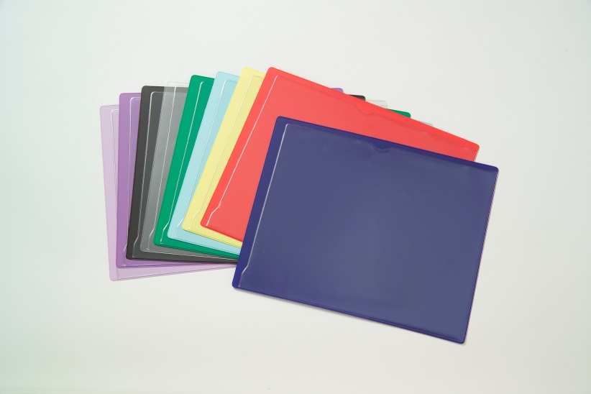
$65.00/box of 50 # CGA-PV-11 Dimensions: 11 ½” x 9 ¼”
Organize and Streamline your paperwork – durable and long lasting – makes routing of documents smoother!
Available colors: Black, Blue, Clear, Frosted Clear, Green, Lavender, Light Blue, Orange, Pink, Purple, Red, Yellow and White.

LETTER-SIZE VINYL OUTGUIDES
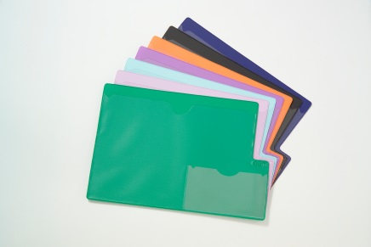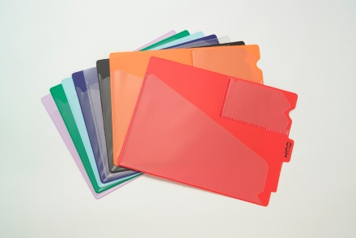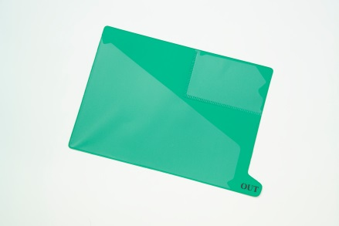
Large Tab Outguides OG-100 Center Tab Outguides OG-224 Bottom Tab Outguides OG-101A
Available colors: Black, Blue, Clear, Frosted Clear, Green, Lavender, Light Blue, Orange, Pink, Purple, Red, Yellow and White.
Stock Number | Size | Tab | Price | Quantity/box
CGA-OG-100 | 9” h x 13 ¼” w | Large, Bottom | $65.00 | 50/box
CGA-OG- 224 | 9 ½” h x 12 ¾” w | Center | $65.00 | 50/box
CGA-OG-101A | 9” h x 13 ¼” w | Small, Bottom | $65.00 | 50/box
Legal-size outguides also available upon request.

