How to use Our clip fastener
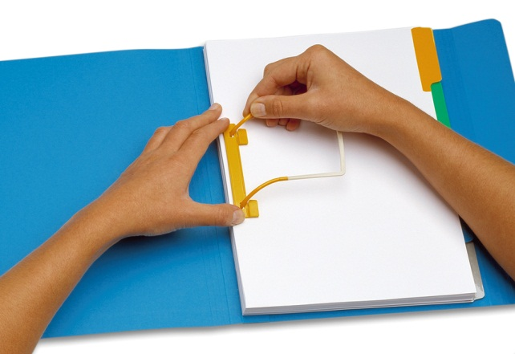 | 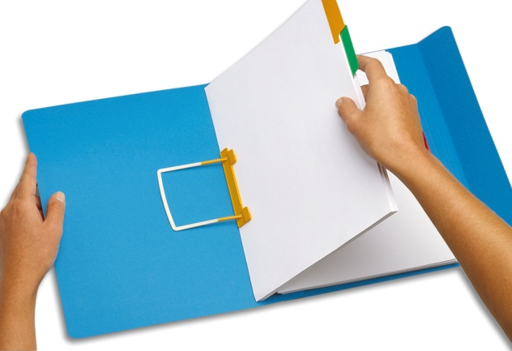
1) UNFASTENING. Using your thumb and forefinger, press down on the ends of the plastic compressor and slide the flexible base out of the tab pieces. | 2) LEAFING. Determine the location in the file where you need to be, and then push the pages in front of it completely to the left on top of the extension.
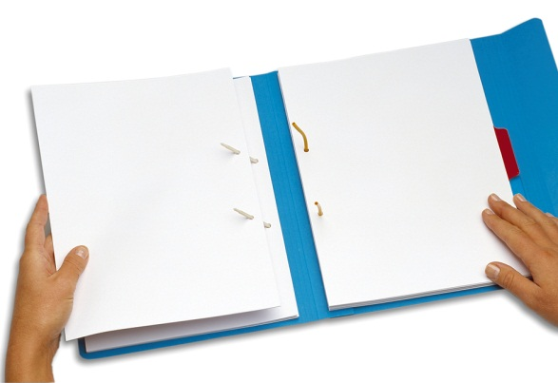 | 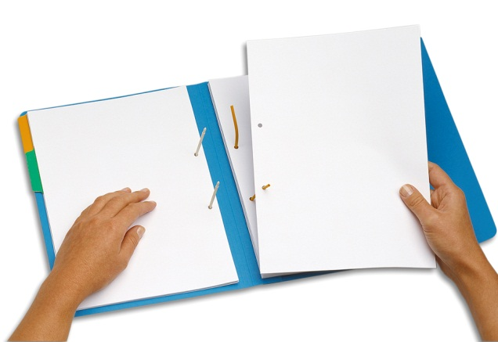
3) OPENING. To open the file, remove the flexible base from the extension. 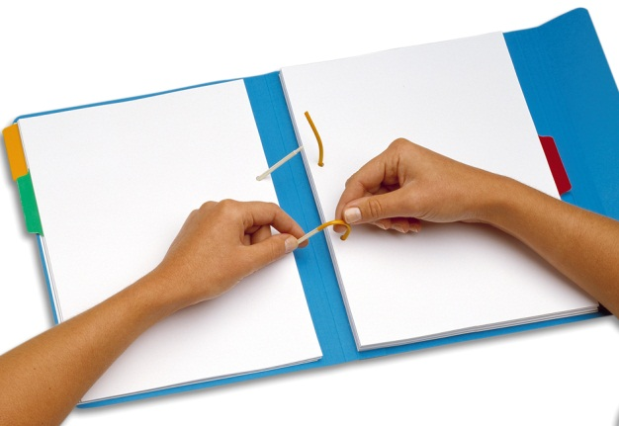 | 4) LIFTING. To remove a document use the flexible base to remove the document. It prevents tearing. 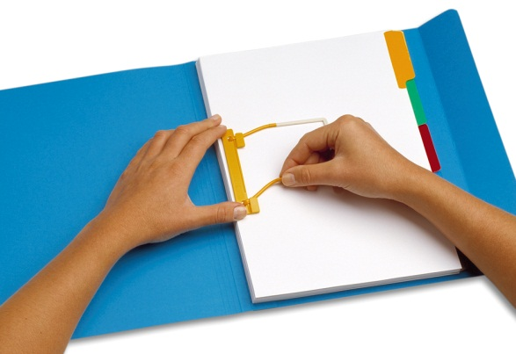
5) INSERTING. To insert documents it is best to make use of the extension on the left side. | 6) CLOSING. Close the device again by following the above instructions in reverse order, making sure to firmly tighten and clamp the flexible base between the tab pieces on the extension.

Contact us for your file folder and chart divider needs!
Charles-Gray Associates / Filing Solutions (877) 277-5215

